Chapter 3: Earthquakes

Earthquakes – result from the rupture of rocks along a fault.

* Rocks on opposite sides of fault move suddenly, and energy is released in seismic waves
* Fault – a fracture in Earth’s crust

Earthquakes:

* Epicentre – is the point on the surface directly above the fault rupture
* Focus (hypocentre) – is the location of the initial rupture along the fault, directly below the epicentre
* At the instant of the rupture, seismic waves radiate outward in all directions from the focus
* Measured by seismographs and compared on magnitude and intensity

Earthquake Magnitude

* Richter Scale – quantified the magnitude of local (California) earthquakes as the logarithm to the base 10 of the maximum signal wave amplitude recorded on a then-standard seismogram at a distance of 100km from the epicentre
  + No longer used.
* Body-wave scale – measure the magnitude of deep earthquakes
* Surface-wave scale – based on earthquake waves that travel along earth’s surface
* TODAY:
  + Moment magnitude – determined from the area that ruptured along a fault plane during the quake, the amount of slippage along the fault, and the rigidity of the rocks near the focus
    - An increase of one whole number to the next represents a 10-fold increase in the amount of shaking and a 32-fold increase in the amount of energy released
    - Ex. Ground motion from a M7 is 10 more than of M6 BUT released 32x more energy
    - Ex. M5 to M7, the energy released is 32x32 greater
* Most damaging earthquakes are major (M7-7.9) or strong (M6-6.9)
  + About 1 Great (M8) or 3 giant (M9) happen each year
  + More than 1 million very minor earthquakes (M less than 3)

Earthquake Intensity

* Depends on magnitude, distance from the epicentre, and the nature of the ground at the site
* Modified Mercalli Intensity Scale measures the degree to which an earthquake affects people, property and the ground
  + 12 categories on this scale are assigned Roman numerals
  + each category contains a description of how people perceive the shaking from an earthquake and the extent of damage to building and other structures
  + ex. I – felt by very few people
  + ex.VI – felt by all. Many people frightened and run outdoors. Heavy furniture moved and a few instances of fallen plaster or damaged chimneys. Damage is slight
  + ex.XII – damage is total. Waves are seen on the ground surface. Lines of sight distorted. Objects are thrown into the air.
* Intensities are commonly shown on maps to show where the damage and perceived shaking is most severed
  + Use seismograph date to show areas of intense shaking
  + Instrumental intensity is used to immediately produce a shake map

Earthquake processes

* Commonly occur at or near plate boundaries
* Plate boundaries may contain faults
* Friction along plate boundaries exerts strain or deformation
* When stress on rocks exceeds their strength, the resulting rupture produced seismic waves

Fault Types – distinguished by the direction of displacement of rocks or sediment bordering them – dip slip or strike slip

Dip Slip

* Vertical movement
* 3 types of dip slip faults based on which way the bounding earth materials move
* walls on an incline are define as:
  + the block below: footwall
  + the block above: hanging wall

1. Normal fault – the hanging wall has moved downward relative to the footwall
2. Reverse fault – the hanging wall has moved up relative to the footwall, fault plane angle is steeper than 45o
3. Thrust fault - the hanging wall has moved up relative to the footwall, fault plane angle is less than 45o
4. Blind faults – buried faults that do not reach the surface

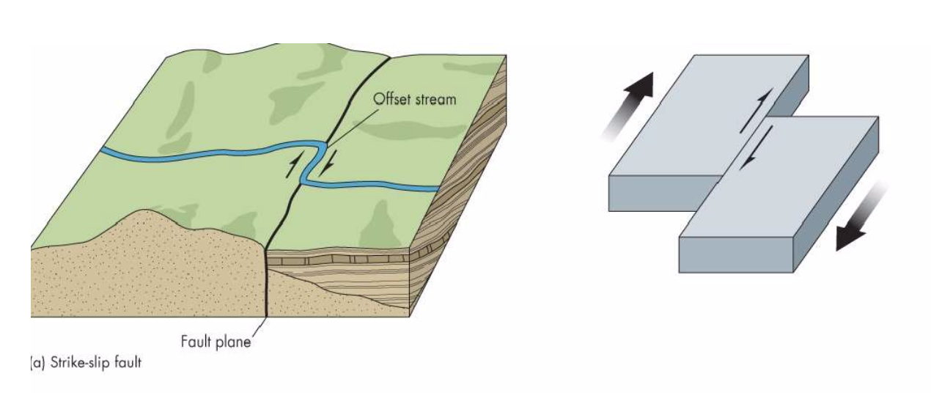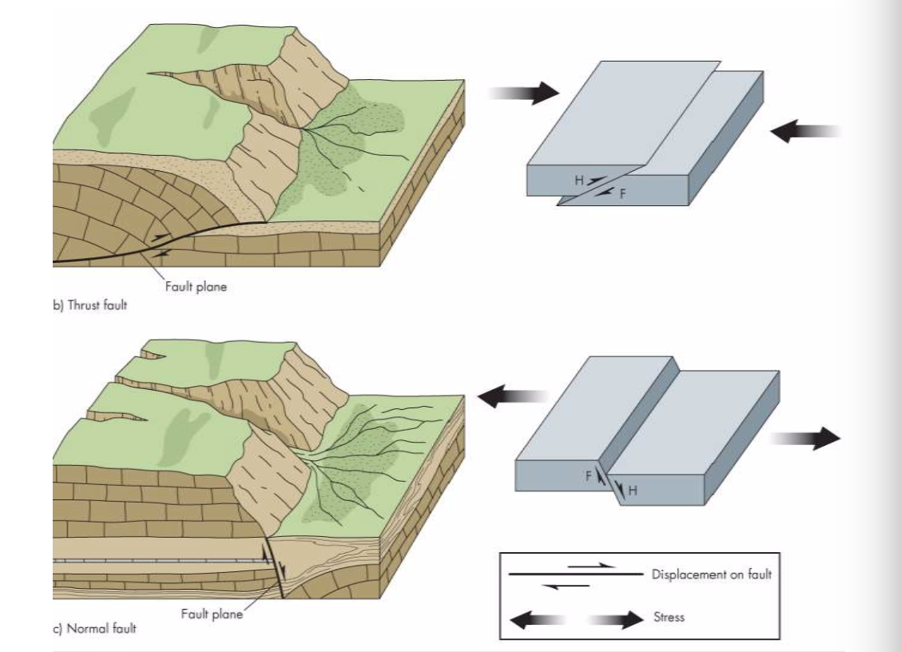

Strike Slip

* Horizontal movement

Active faults – movement during the past 11600 years

Potentially active faults – movement during the past 2.6 million years

Inactive faults – no movement during the past 2.6 million years

Tectonic creep (fault creep) – occurs when movement along a fault is so gradual that earthquakes are not felt

* This can slowly damage infrastructure

Slow earthquakes – similar to other earthquakes as they are produced by fault rupture but rather than instantaneous, they can last from days to months

Seismic Waves – Body waves

* Travel within the body of the earth
* Two types:
  + P waves (primary or compressional waves) – can travel through any type of material although their velocity in solids is much higher than in liquids
    - Push pull effect, move very fast
  + S waves (secondary or shear waves) – travel only through solid materials
    - Move slowly with a back/forth motion at right angles to the direction the waves are moving

Seismic Waves – Surface Waves

* Travel along earth’s surface horizontally and vertically and can produce a rolling motion
* Move more slowly than body waves
* Responsible for damage near the epicenter
* Two types:
  + Love waves – cause horizontal shaking, especially damaging to foundations
  + Rayleigh waves – rolling waves, elliptical motion

Distance to the Epicentre and focal depth

* Earthquake shakes generally decrease with distance from the epicentre
* Epicentre is located using the P and S waves detected by seismographs
* Digital record of the waves is called seismograms
* Seismographs record arrivals of waves to station sites
  + P waves and S waves travel at different rates and arrive at each station at different times
  + Distance to the epicentre can be found by comparing travel times of the waves using triangulation
* Focal depth influences amount of shaking due to attenuation (loss of energy)

Local soil and rock conditions

* Local geology influences amount of ground motion during an earthquake
  + Dense rocks transmit earthquake energy quickly
  + Seismic waves slow down in heterogeneous rocks, unconsolidated sediment and sediment with high water content
* Alluvial occurs when energy is transferred from P waves to S waves to surface waves
* More damage can occur in areas further from epicentre depending on local ground conditions

Earthquake Cycle – idea that stored elastic strain drops abruptly after an earthquake and then slowly accumulates until the next quake

1. Inactive period where stress builds in the fault
2. Period of small earthquakes where the stress begins to release, causing strain
3. Foreshocks occur prior to a major release of stress (does not always occur)
4. Mainshock – when the fault releases the majority of the stress
5. Aftershocks – releases of stress after a major earthquake

Earthquakes are not randomly distributed – most occur along plate boundaries

* But not all areas at risk are near plate boundaries

Plate boundary earthquakes – occur on faults separating lithospheric plates

1. Strike slip earthquake – occur on transform faults where lithospheric plates slide horizontally past one another
2. Thrust earthquakes – on faults separating converging plates
   * Subduction earthquakes are the largest on earth, some that are even larger than M9. Create giant earthquakes that displace seafloor upward and laterally over massive areas – typically triggering tsunamis
3. Normal dip slip earthquakes – occur on diverging plate boundaries, located in oceans far from land and typically are no larger than a M6

Intraplate Earthquakes – occur within lithospheric plates rather than at their boundaries, can be large and extremely damaging

* Although small, they travel greater distances through dense continental bedrock than plate boundary earthquakes

Effects of Earthquakes and linkages

* Shaking: the intensity of seismic shaking is commonly expressed as a ratio of ground acceleration to the acceleration of gravity
  + Causes damages to infrastructure
  + Resonance – if the frequency of the shaking matches the natural vibrational frequency of the building
* Ground rupture: displacement along the fault causes cracks in the surface and fault scarps (low cliff that extends for hundred of meters to km along the fault)
* Liquefaction: water-saturated loose sediment turns from solid to liquid, causing buildings and land to subside
  + Watery sand or silt can also flow upward along fractures in overlying solid materials and erupt onto the surface as sand blows/sand volcanoes
* Land level changes: earthquakes that cause the land to raise or lower
* Landslides: ground motions produced by a large earthquake can cause rock or sediment to fail and move downslope
* Fires: ground shaking and surface rupture can sever electrical power and gas lines
* Disease: a loss of sanitation and housing, contaminated water supplies and disruption of public health services all contribute

Natural service functions of earthquakes

* Water, oil and natural gas may be rerouted due to faults
* Fault zones provide paths for the downward flow of surface water
* Faults can channel ground water to the surface at discharge points called springs
* New mineral sources may be exposed, typically deposited along faults called veins
* Landform development

Human activities can trigger small to moderate sized earthquakes

* The weight from water reservoirs may create new faults or lubricate old ones
* Liquid waste disposals deep in earth can create pressure on faults
* Pumping of oil and gas and hydraulic fracturing (fracking) can cause small earthquakes
  + Fracking is a techniques used to enhance hydrocarbon production by releasing natural gas or petroleum from a subsurface rock layer
* Nuclear explosions can cause the release of stress along existing faults

Earthquake Hazard Reduction Programs

* 5 major goals:
  + operate national seismograph networks
  + develop an understanding of earthquake sources
  + determine earthquake potential
  + predict effects of earthquakes on building and other structures
  + communicate research on order to educated individuals, communities, and governments

Estimating Seismic Risk

* hazard maps are used to show earthquake risk
* show locations of epicentres of historic earthquakes of different magnitudes
* probabilities of earthquakes of different sizes or the amount of shaking likely to occur
* ground acceleration zones
* slip rate – the average displacement rate on the fault measured over thousands of years and numerous earthquakes
* paleoseismologists – geologists who examine recent geologic record of faulting to determine times and sizes of prehistoric earthquakes

Approaches used to anticipate future earthquakes

* forecasting – specifies the probability of an earthquake occurring with specified magnitude, time and area
* prediction – an earthquake of a given magnitude will occur in a define region with a restricted period of time

precursors

* pattern and frequency of earthquakes
  + forshocks
  + micorearthquakes – M less than 2 happening for several months before the major shocks
* land level change
  + uplift
  + subsidence
* seismic gaps align faults
  + areas that have not seen recent earthquakes
* physical and chemical changes in earth’s crust
  + changes in electrical resistivity and groundwater levels, temperatures and chemistry

Earthquake warning systems – current warning systems provide 15 seconds to a minute of warning

Perception – one community’s experience does not stimulate other communities to improve their preparedness

* critical facilities located in earthquake safe locations
* ground response maps to seismic shaking
* buildings designed to withstand vibrations
* retrofitting old buildings
* education
* insurance availability